MILTON UNDER WYCHWOOD ALLOTMENTS & GARDENS ASSOCIATION
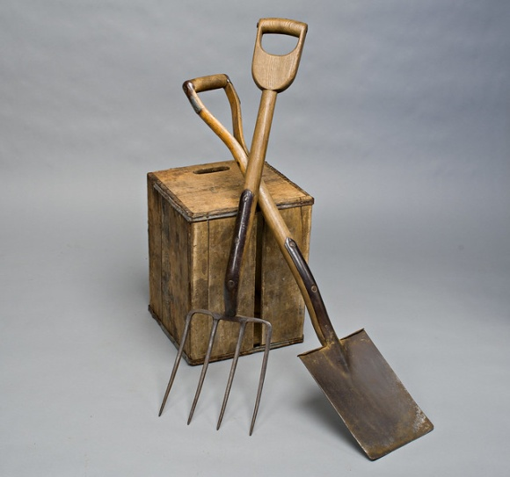


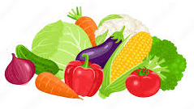

ANNUAL SHOW 2026

Teas Raffle Prizes

The Annual Show will be held in the MILTON VILLAGE HALL on SATURDAY 15th AUGUST 2026 at 2pm.

Classes are open to all members and non-members living in Ascott, Milton or Shipton under Wychwood, children attending a local school or any child with grandparents living in the Wychwood villages.
New entrants are particularly welcome!
An entry form and class schedule are attached.

Please return your entry by 4pm on THURSDAY 13th AUGUST 2026 to the box at Groves, the Library,
Di Fletcher at Forest Lodge, Frog Lane or Sandy Bradshaw at Quakers Meet, Green Lane.

PLEASE NOTE: THERE ARE NO FEES FOR ENTERING EXHIBITS THIS YEAR

EXHIBITORS ARE ASKED TO NAME THE VARIETY OF FRUIT, FLOWER OR VEGETABLE WHEREVER POSSIBLE TO ADD INTEREST TO THE SHOW

9am Doors open for exhibitors – please respect the needs of all competitors and leave the hall when
staging is complete
10.15 All staging completed and hall cleared for judging
10.20 Judging
2pm Doors open to the public
3.30 Prize Presentation and Raffle
4pm Exhibits removed

ENTRY TO HALL FROM 2pm FOR VIEWING – 50p

Copies of RHS (Vegetables & Fruit) Handbook are available from the library. Please look at them for standards and rules of presentation.

MILTON UNDER WYCHWOOD ALLOTMENTS & GARDENS ASSOCIATION

2026 ANNUAL SHOW Schedule of Classes

The Dr Scott Memorial Shield will be awarded to the best entry in the Show

VEGETABLES
President’s Cup for the most points 001-022

001 | Bean French - Pencil | 6
002 | Bean - Runner | 6
003 | Beetroot | 4
004 | Cabbage | 2
005 | Carrot | 3
006 | Carrot - Stump Root | 3
007 | Courgette | 3
008 | Cucumber | 2
009 | Garlic | 2 heads
010 | Herbs - Culinary | 4 herbs in a glass container
011 | Onion - under 250g | 3
012 | Onion - over 250g | 3
013 | Onion - Red | 3
014 | Pepper or Chilli | 3 of a single variety
015 | Potato - Coloured | 4
016 | Potato - White | 4
017 | Shallot | 5
018 | Tomato - Standard | 6
019 | Tomato - Cherry Red | 6
020 | Tomato - Cherry Yellow/Orange | 6
021 | Tomato Selection | 3 of each of 3 varieties
Mervyn Dore Cup for Best Tomato Exhibit
022 | 4 Salad Items | On a dinner plate
Hawtin Cup for 023
023 | Selection of Vegetables | 1 each of 4 different varieties
024 | Vegetable not in another class | 1 piece
025 | Pair of Marrows | Any size
026 | Funniest Shaped Vegetable

FRUIT
Association Cup for most points 030-031

030 | Soft Fruit | 2 varieties on a plate
031 | A collection of fruit on a plate | 3 different varieties
032 | Dessert Apples | 5 on a plate
033 | Cooking Apples | 5 on a plate

PHOTOGRAPHY

040 | ‘Close up in the Garden’ | See ‘Tips’
041 | ‘Nature in the Locality’ | See ‘Tips’
042 | ‘Portrait of a Gardener’ | See ‘Tips’
For Children’s Photography classes see page 4

FLOWERS
Wychwood Cup for most points 050-053

050 | Dahlias – any variety/colour | 3 stems of one variety in a vase
051 | ‘Perfect but Lonely’ | 1 single flower in a vase
052 | Favourite flowers of 2 or more varieties | Any 5 stems, any container
053 | 1 stem each of different cut annuals/perennials | In a glass vase

Miles Brown Cup for best exhibit Roses

054 | Roses | 3 of any kind
055 | Roses Hybrid Tea | 2 of a single variety
056 | Roses Multi-headed | 2 of a single variety

057 | Pot plant of any variety | Plant must have been in your possession for at least a year. Shown in a pot, no bigger than 30cm

BEVERAGES

060 | Homemade wine | 1 bottle
061 | Homemade beer or cider | 1 bottle
062 | Homemade cordial | 1 bottle
063 | Spirit based fruit aperitif eg sloe gin | 1 bottle

FLOWER ARRANGING
Bought flowers, foliage and accessories permitted unless otherwise stated
All exhibits to be no more than w46cm x d46cm, height unrestricted
Flower frogs and chicken wire can be used, but not oasis
Vicarage Field Cup for most points 070-073
Pat Burgis Cup for best flower arrangement – public vote

070 | A Book Title of your choice | Accessories allowed
071 | ‘Where have all the flowers gone?’ | Foliage only
072 | ‘Small and Lovely’ | Arrangement in a liqueur glass. Height 18cm
073 | ‘Holiday’ | Accessories allowed

COOKERY
Please cover all exhibits, jams must be covered with wax disc

Frogmore Cup for most points for 080-088

080 | Lemon Curd | 1 jar
081 | Jam | 1 jar
082 | Marmalade | 1 jar
083 | Chutney | 1 jar
084 | Savoury Scones | 4 on a plate
085 | Flour-free cake (gluten free)
086 | Flapjacks | 5 on a plate
087 | One white loaf | Oven baked
088 | Lemon Drizzle Cake | Loaf tin

O89 | Eggs | 3 on a plate or saucer  See ‘Tips’
090 | Honey | 1 jar

CRAFTS
The theme is ‘Nature’
Only items produced in 2025/6 should be entered

100 | A small craft item | No larger than 30cmx30cm
101 | A small painting | No larger than A3  Can be framed

CHILDREN
The following classes are open to children up to age 14 but will be judged in 2 sections - under 11
years and 11-14 years. Child’s age to be clearly shown on entry and to be own work.

110 | A Lego vehicle (No kits) | Under 11
111 | A Lego vehicle (No kits) | Age 11-14
112 | 3 cupcakes on a plate | Under 11
113 | 3 cupcakes on a plate | Age 11-14
114 | An animal made mostly of vegetables | Under 11
115 | An animal made mostly of vegetables | Age 11-14
116 | Drawing or painting of a hedgehog  (No larger than A3) | Under 11
117 | Drawing or painting of a hedgehog  (No larger than A3) | Age 11-14
118 | ‘Something I have grown’ | All ages
119 | ‘My Dream Garden’  (No larger than A3) | All ages  See ‘Tips’
Photography
120 | ‘What I found in my Garden’ | Under 11
121 | ‘What I found in my Garden’ | Age 11-14

GENERAL TIPS FOR SUCCESSFUL SHOWING
- Read the schedule carefully – put the correct number of items
- Soft and hard fruits need to be exhibited with their stalks on
- French beans, runner beans, peas and tomatoes need to be harvested with scissors
with some stalk attached
- For root vegetables, such as carrots, cut off leaves to approximately 3 inches
- A set of evenly sized exhibits can be better than the largest (except where large are
asked for)
- More unusual herbs are preferred
- Cover all food
- All jams, chutneys and marmalade should be covered with a waxed disc and a new
lid of either cellophane or metal
- Label jam, jelly and chutney with type and date
If you require more information please refer to The Horticultural Show Handbook (RHS).

TIPS FOR PHOTOGRAPHY CLASSES
- Prints should be between A4 and A5 in size and not framed
- Editing of photographs is permitted eg to adjust exposure or contrast, and also cropping to remove any imperfections or unwanted details. Entries should note when and what kind of editing was employed
- The use of AI is prohibited
- All entries should have been taken since the last MUWAGA show in August 2025
- The judges will be looking for originality and technical proficiency but with the emphasis on originality
- Class 040 – Photographs should be taken using a close-up lens and can be abstract in nature

JUDGING CRITERIA FOR CLASS 089
Eggs will be judged on
- their external quality - colour, size, cleanliness, texture and, most importantly, uniformity
and
- their internal quality - a firm, compact, upstanding albumen with a well-coloured, domed yolk centrally sited in the albumen

TIPS FOR CHILDREN’S CLASS 119
- Imagine what your dream garden would be like and draw a design, with labels, on paper
- You could choose a theme such as a seaside garden, a miniature garden or wildlife garden
- Think about what you would like to do in your garden and what you would put into it - perhaps a pond, a treehouse, a barefoot area or a play zone
- Don’t forget to include plants in your design too

MILTON UNDER WYCHWOOD ALLOTMENTS & GARDENS ASSOCIATION

ANNUAL SHOW ENTRY FORM

FILL IN THE NUMBERS OF THE CLASSES YOU WISH TO ENTER
THE ASSOCIATION ACCEPTS NO RESPONSIBILITY FOR LOSS OR DAMAGE TO EXHIBITS

PLEASE NOTE: THERE ARE NO ENTRY FEES THIS YEAR

I CONFIRM THAT THESE ENTRIES CONFORM TO THE RULES OF THE SHOW AND HAVE BEEN
GROWN BY OR ARE THE HANDIWORK OF THE EXHIBITOR UNLESS OTHERWISE STATED

NAME…………………………………………………………..….TEL NO……………………………………………

CHILD’S AGE………………….

SIGNATURE…………………………………………..………….DATE………………………………..

,
RETURN TO: The box at Groves, the Library, Di Fletcher at Forest Lodge, Frog Lane or
Sandy Bradshaw at Quakers Meet, Green Lane

CLOSING DATE FOR ALL ENTRIES – 4pm on THURSDAY 13TH AUGUST 2026

NO LATE ENTRIES ACCEPTED

